DB Services

AWS Task 4
Tamar Tutisani

Contents
Executive Summary 3
1 RDS MySQL 3
1.1 Locating the RDS MySQL Instance 3
1.2 Connecting via DBeaver Using Admin Credentials 3
1.3 Creating My Own MySQL User 4
1.4 Reconnecting as My Own User 5
1.5 Writing a Restartable Initial Script 5
1.6 Verifying the Database Objects 6
2 RDS Aurora 8
2.1 Why Aurora Requires a Bastion/SSH Tunnel (The Key Conceptual Point) 8
2.2 Exploring Aurora via the Query Editor (Browser-Based) 8
2.3 Finding the Aurora Endpoint 10
2.4 Setting Up SSH Tunnel Through the Bastion (EC2) 11
2.5 Cloud9 (Optional): Attempted but Blocked by IAM Permissions 13
3 DynamoDB 15
3.1 Manual Console-Based Table Creation (Warm-Up) 15
3.2 Creating the Real Table via AWS CLI 16
3.3 Batch Loading 20+ Items 18
3.4 Retrieving 5+ Rows Using Keys (get-item) 19
3.5 Running Several "Select"-Style Queries 22
3.6 Deleting 2 Rows and Verifying Count 25
SUMMARY AND FINDINGS 26

Executive Summary
This lab covers three AWS database services, RDS MySQL, RDS Aurora, and DynamoDB, each representing different database paradigms and architectural patterns in the cloud. For MySQL, I provisioned a standalone relational database, created a schema and initial setup script, and verified connectivity via DBeaver. For Aurora, I explored both the AWS Query Editor (browser-based) and established a secure SSH tunnel through an EC2 bastion host to connect from my local machine, demonstrating the private VPC security model. For DynamoDB, I transitioned from console-based manual operations to AWS CLI automation, learning NoSQL data modeling, batch operations, and query patterns.

RDS MySQL

Locating the RDS MySQL Instance
The task mentioned that mentors had already provisioned one or two RDS MySQL databases. I opened the AWS Console, navigated to the RDS service, and found three databases listed: dilab-aurora, dilab-aurora-1 (Aurora instances), and dilab-mysql (the MySQL Community instance I needed). The dilab-mysql instance showed status "Available" and Engine "MySQL Community," confirming it was ready to use.

Connecting via DBeaver Using Admin Credentials
I opened DBeaver and created a new MySQL connection. Rather than guessing the endpoint, I clicked on the dilab-mysql instance in the RDS console and scrolled to the Connectivity & security section, where I found the endpoint: dilab-mysql.cqlpneuyr8on.eu-central-1.rds.amazonaws.com and port 3306. I filled in DBeaver's connection dialog as shown in Figure 1.
When I clicked Test Connection the test succeeded (Figure 2).
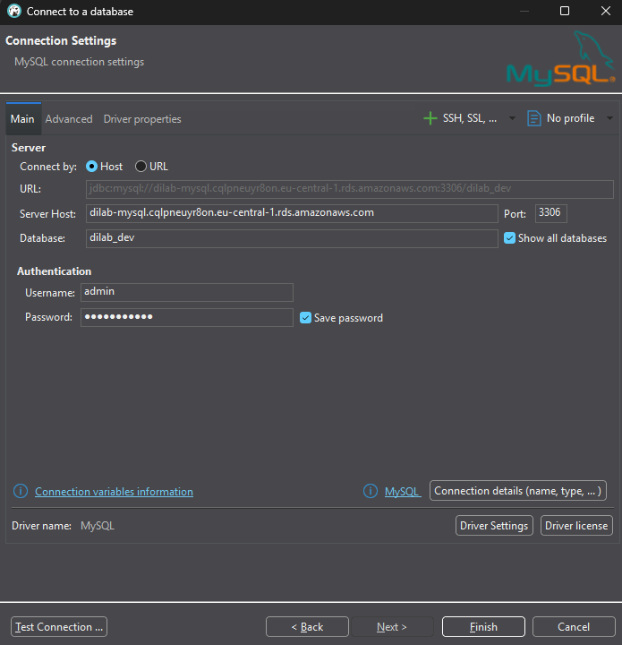
Figure 1. DBeaver MySQL connection settings

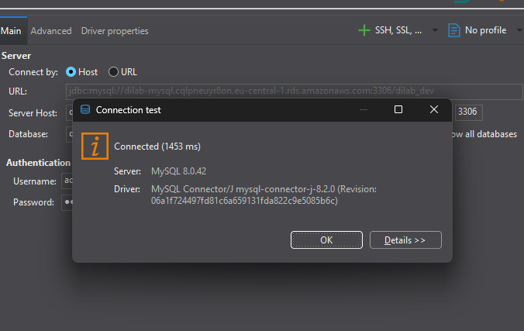
Figure 2. Successful connection test

Creating My Own MySQL User
All further work is supposed to be done as my own user, not the admin account, so I opened a SQL editor in DBeaver and ran a CREATE USER and GRANT PRIVILEGES script shown in Figure 3.
This created a new user tutisani with a strong password and granted all permissions on the dilab_dev database. The '%' wildcard allows connection from anywhere (in a real environment, you'd restrict this to specific IPs).
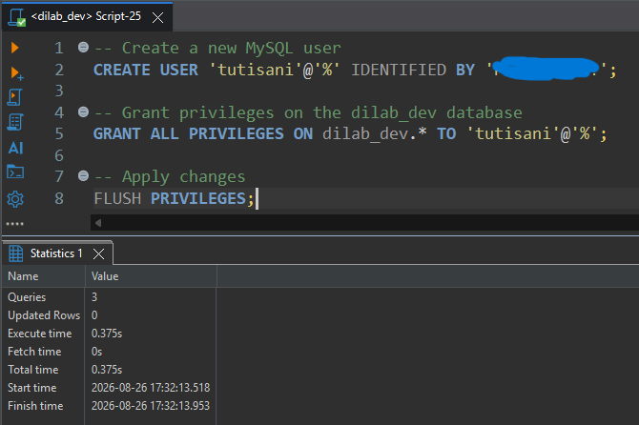
Figure 3. Creating own MySQL user

Reconnecting as My Own User
To ensure I wasn't relying on the admin account, I created a second DBeaver connection with the same endpoint and database, but with my new credentials:
- 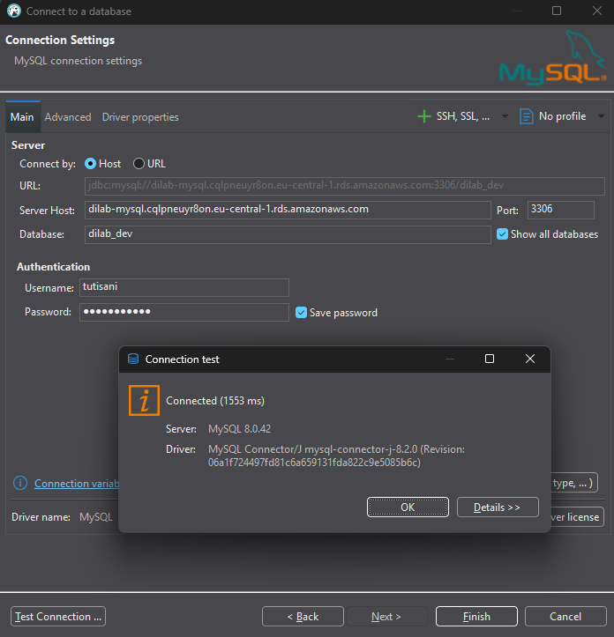
Figure 4. Connected as own MySQL user
Testing this connection confirmed it worked independently.

Writing a Restartable Initial Script
The task demanded an "initial script" that could safely re-run without errors, meaning every statement needed CREATE ... IF NOT EXISTS or CREATE OR REPLACE to be idempotent. I created a comprehensive script that:

- Created a database (schema) for my work: tutisani_schema
- Created a simple but realistic employees table with columns for ID, name, department, hire date, and salary
- Inserted sample data with a safety check to avoid duplicates on re-runs
- Created a view (vw_high_earners) that filters employees earning over $50,000
- Created a stored procedure (prc_get_employees_by_dept) that accepts a department name and returns matching employees
I ran the entire script in one go and verified all three objects were created successfully.
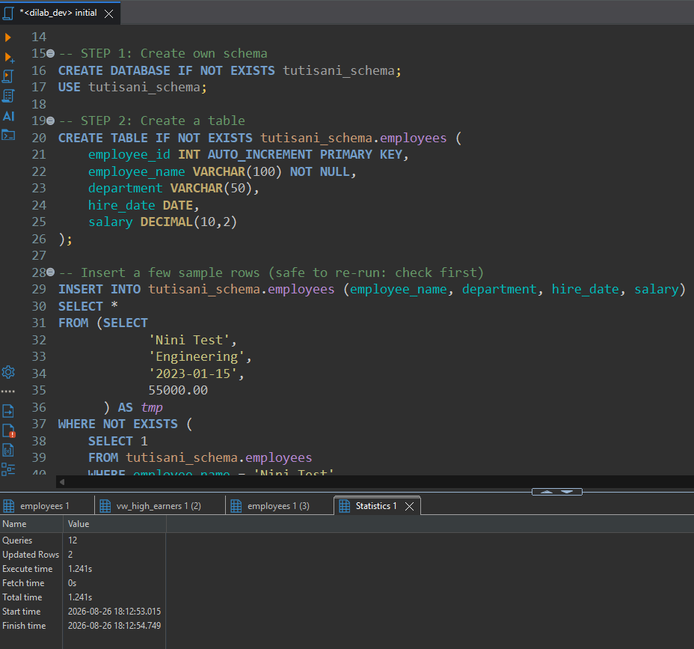
Figure 5. Initial script execution
The full initial script is provided as a separate file, initial.sql, alongside this report.

Verifying the Database Objects
I then ran individual verification queries to confirm each object was functional:
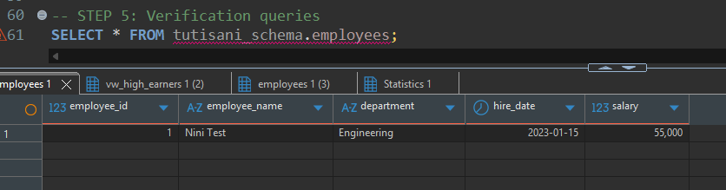
Figure 6. Employees table data
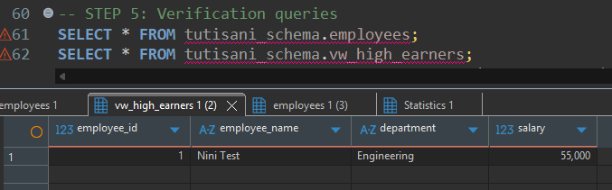
Figure 7. View result
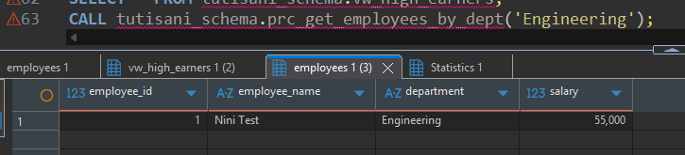
Figure 8. Stored procedure result
This completed Task 1. I had successfully created a database, established my own user account, and built a restartable initialization script with a table, view, and procedure.

RDS Aurora

Why Aurora Requires a Bastion/SSH Tunnel (The Key Conceptual Point)
Before connecting, the task asked: "Describe why it is the only way to connect to Aurora from local PC opposed to Amazon RDS MySQL."
The answer lies in networking architecture. MySQL (dilab-mysql) is likely deployed with a public endpoint, meaning its DNS name resolves from the internet and it accepts incoming connections on port 3306 from anywhere (subject to security groups). I can connect directly from my laptop because EPAM VPN gives me general internet access.
Aurora (dilab-aurora-1), by contrast, is deployed inside a private VPC subnet. Its endpoint only resolves within that VPC, externally, it's unreachable. This is a deliberate security practice: production databases typically live in private subnets to minimize attack surface. To access it from my laptop, I must:
- Connect via SSH to an EC2 instance that sits inside the same VPC (my bastion/jump host from Task 2)
- Use SSH tunneling to forward local port 3306 to the EC2's local 3306, which can reach Aurora
- DBeaver then connects "locally" on port 3306, and the tunnel silently routes traffic through the EC2
This is the only practical way because the alternative, adding Aurora to a public subnet, would defeat the purpose of having a private database.

Exploring Aurora via the Query Editor (Browser-Based)
For a quick initial check, AWS provides a Query Editor directly in the console, no bastion needed. I navigated to RDS > Query Editor. It prompted for credentials shown in figure 9.
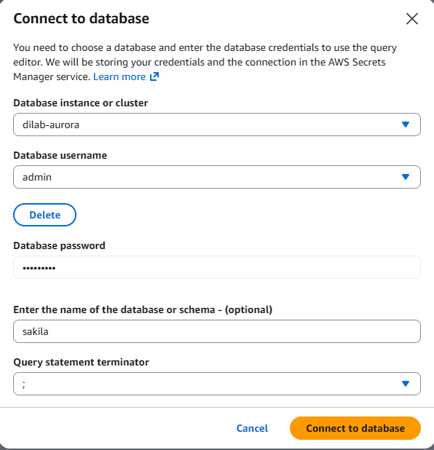
Figure 9. Aurora Query Editor connection
Once connected, I had a browser-based SQL interface. To demonstrate non-trivial queries, I wrote two analytical queries against the sakila sample database:
Query 1: Top rented film categories
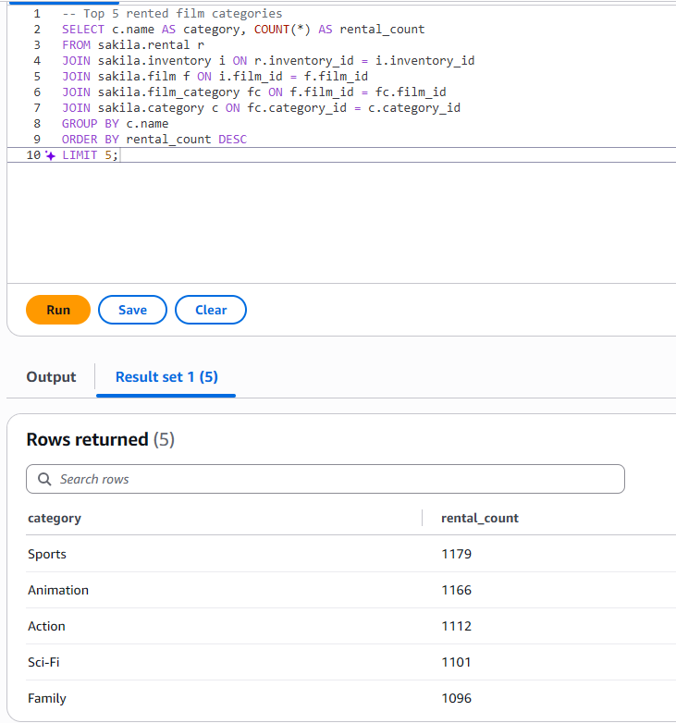
Figure 10. Top rented categories query
This query joined four tables and aggregated rental counts by category.

Query 2: Top paying customers
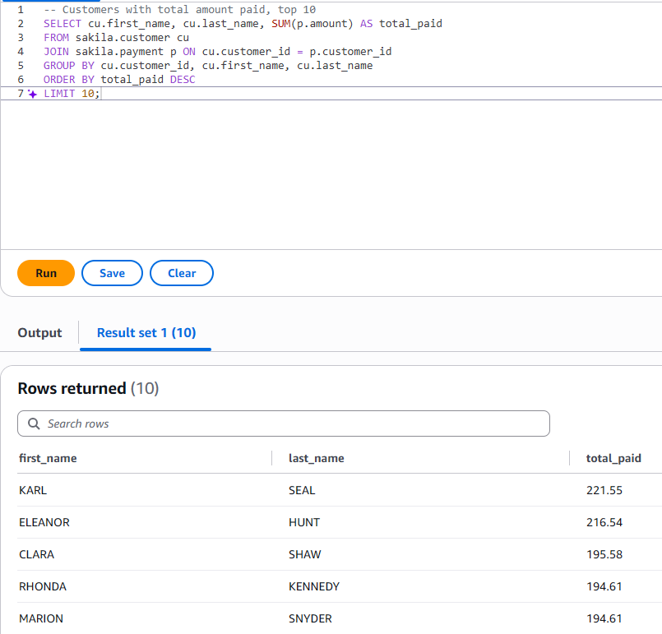
Figure 11. Top paying customers query
This aggregated total payments per customer, also a realistic analytical workload.

Finding the Aurora Endpoint
Just like MySQL, I located the Aurora endpoint in the RDS console. Clicking dilab-aurora-1 and navigating to Connectivity & security showed the endpoint: dilab-aurora-1.cqlpneuyr8on.eu-central-1.rds.amazonaws.com on port 3306.
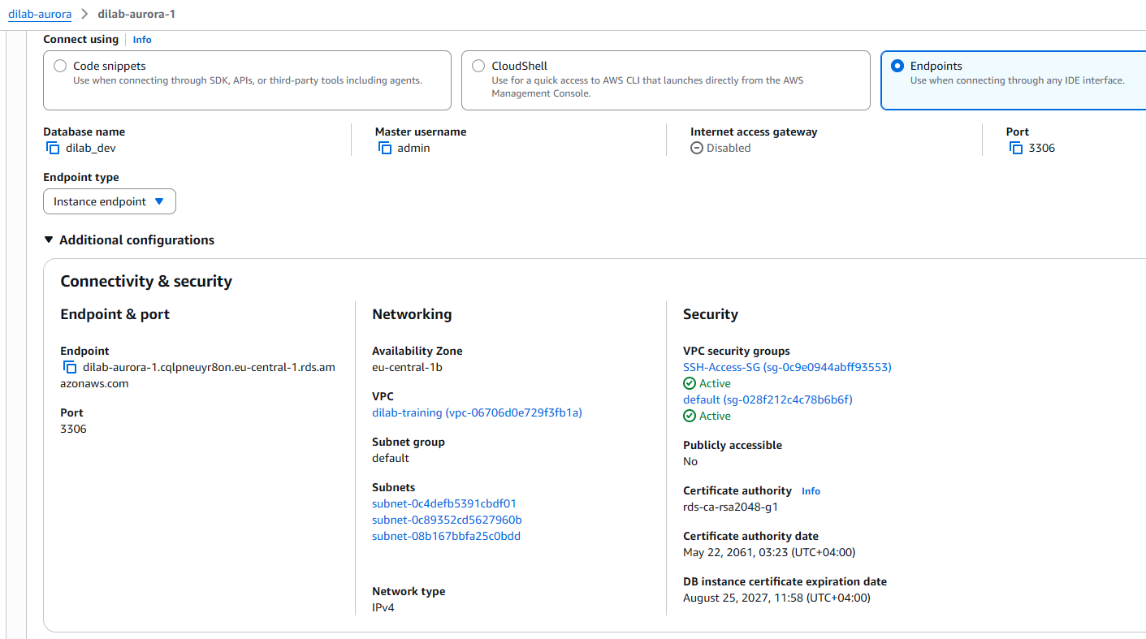
Figure 12. Aurora endpoint

Setting Up SSH Tunnel Through the Bastion (EC2)
I already had an EC2 instance from Task 2 (tutisani-ec2-pg) running in the same VPC as Aurora. I needed to:
- Retrieve my EC2's public IP. Found in EC2 console > Instances > tutisani-ec2-pg > Public IPv4 address
- Locate my private key - the .pem file I downloaded when creating the instance.
- Configure DBeaver's SSH tunnel
In DBeaver, I created a new MySQL connection:
- Server Host: dilab-aurora-1.cqlpneuyr8on.eu-central-1.rds.amazonaws.com (the Aurora endpoint)
- Port: 3306
- Database: sakila
- Username: admin
- Password: admin_aurora
Then I clicked the SSH tab and enabled "Use SSH Tunnel":
- Host/IP: 18.192.178.216 (my EC2's public IP)
- Port: 22
- Username: ec2-user
- Authentication: Public Key
- Private Key: (browsed to my .pem file)
I tested the tunnel configuration first, which verified SSH connectivity to the EC2. Once that passed, I tested the full database connection, which went: DBeaver > SSH tunnel > EC2 > Aurora. Success.
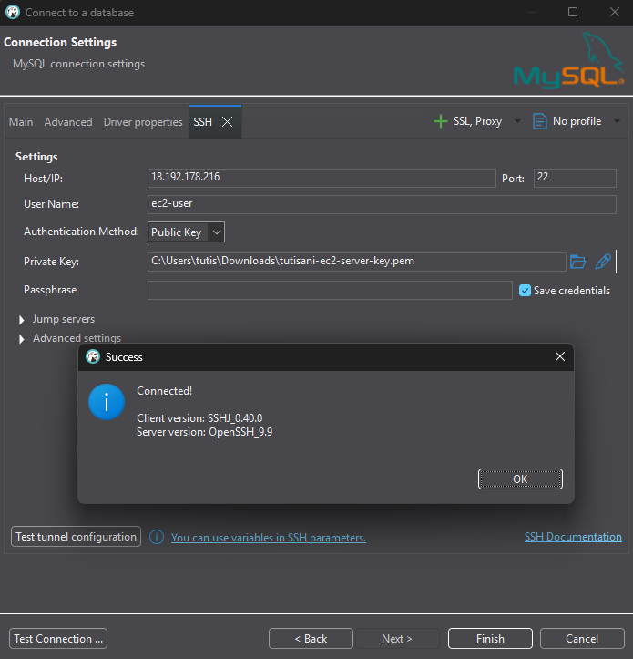
Figure 13. SSH tunnel configuration and successful connection
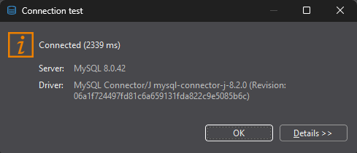
Figure 14. Aurora connection successful
I then ran a query through the tunnel to prove end-to-end functionality:
SELECT * FROM sakila.film LIMIT 10;
This returned film data directly from Aurora, routed through the EC2 tunnel.

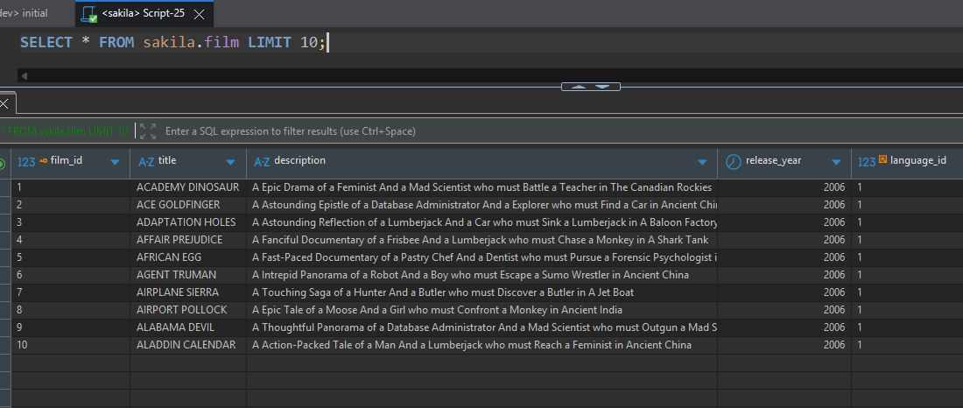
Figure 15. Query via SSH tunnel result

Cloud9 (Optional): Attempted but Blocked by IAM Permissions
I attempted to launch a Cloud9 environment as another means of connecting to Aurora (since Cloud9 sits in the VPC and could reach Aurora directly). However, two permission errors blocked me:
- First attempt failed: cloud9:TagResource permission denied when trying to add the owner=student tag
- Second attempt (removing the tag): iam:CreateRole permission denied, Cloud9 tried to auto-provision the AWSCloud9SSMAccessRole required for Systems Manager-based connectivity, but the students-role policy doesn't grant IAM role creation to students
Both failures stem from intentional IAM restrictions on the students-role.

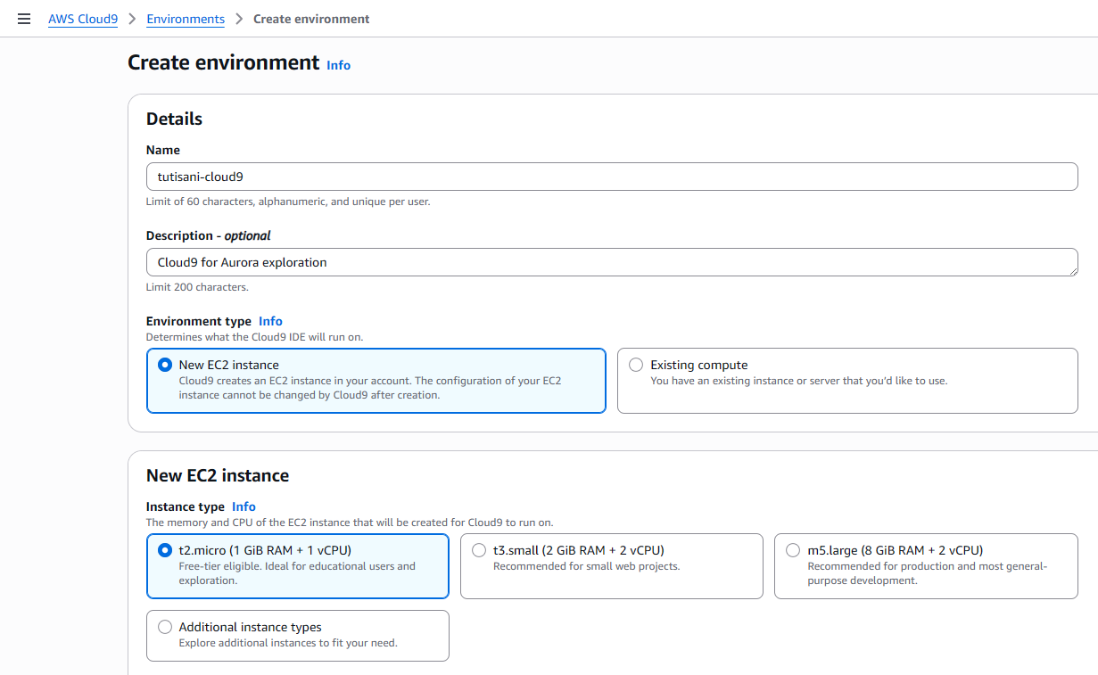
Figure 16. Cloud9 environment configuration
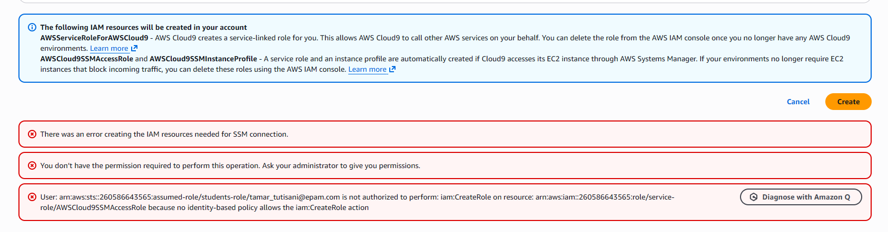
Figure 17. Cloud9 creation blocked: missing iam:CreateRole permission for SSM role
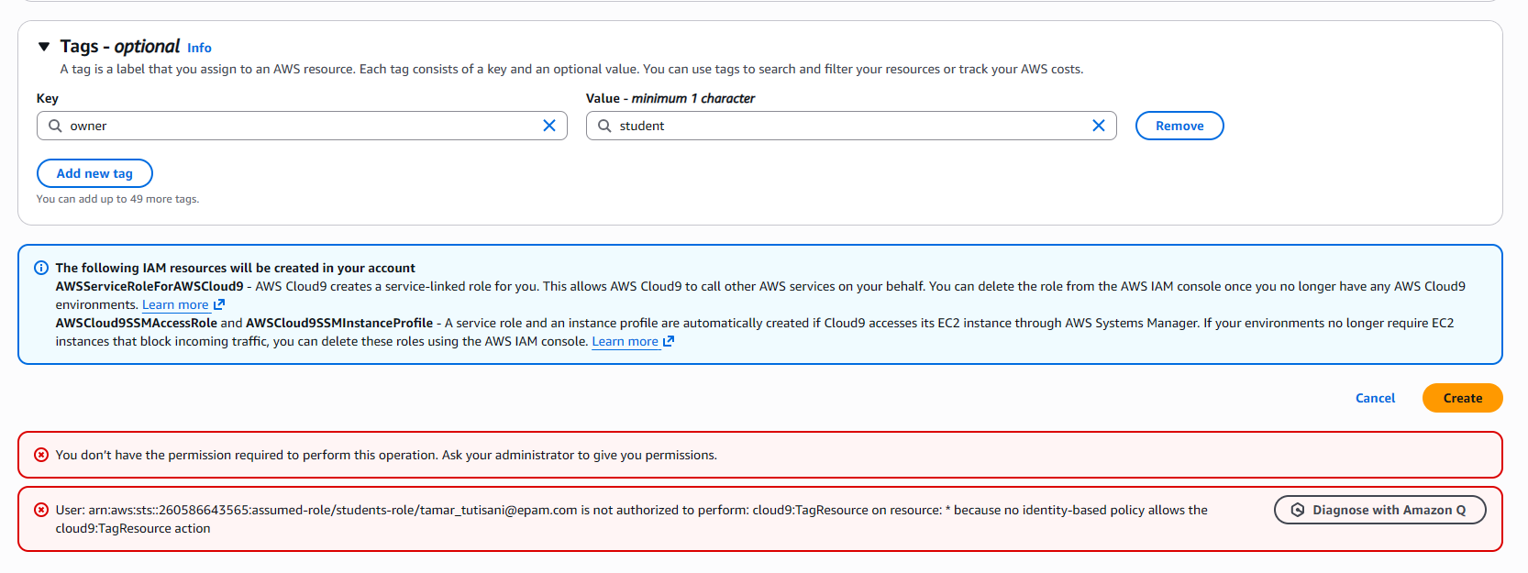
Figure 18. Cloud9 creation blocked: missing cloud9:TagResource permission

DynamoDB

Manual Console-Based Table Creation (Warm-Up)
DynamoDB is very different from relational databases, it's a NoSQL key-value store with no schema enforcement and a completely different query model. To get familiar with the console, I created a throwaway table manually:
- RDS console > searched for DynamoDB > opened DynamoDB service
- Clicked "Create table" and filled in:
  - Table name: tutisani-test-table
  - Partition key: id (type String)
  - Left sort key empty (optional)
  - Added tag owner=student
- Once active, I clicked "Explore table items" and manually created a few items via the console UI (clicking "Create item," adding attributes like name).
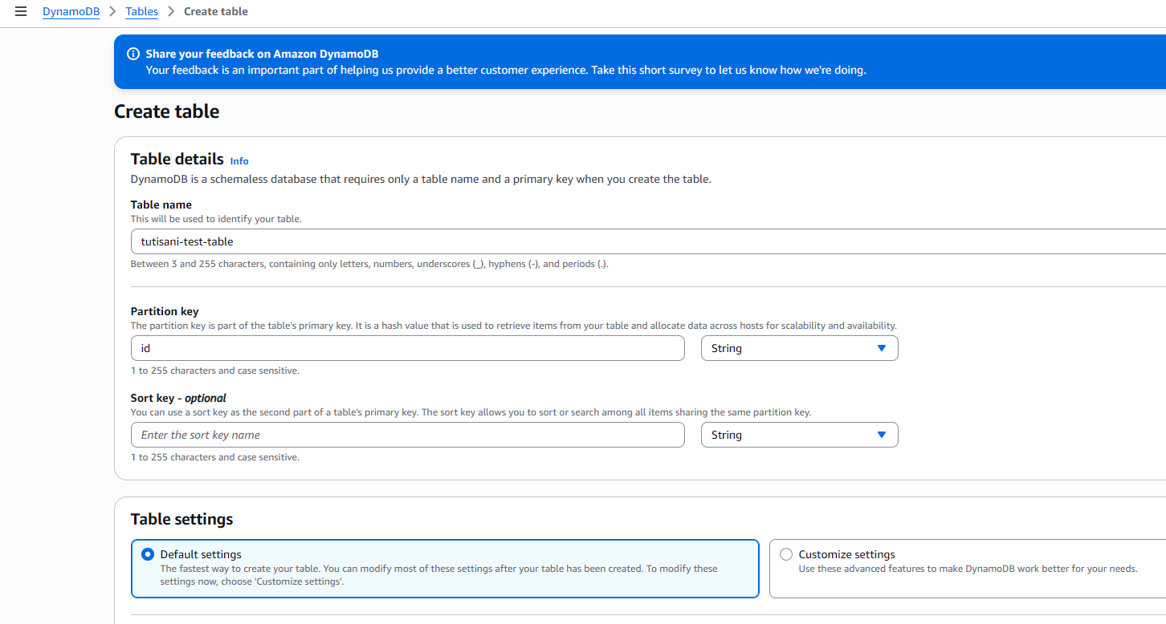
Figure 19. DynamoDB table creation

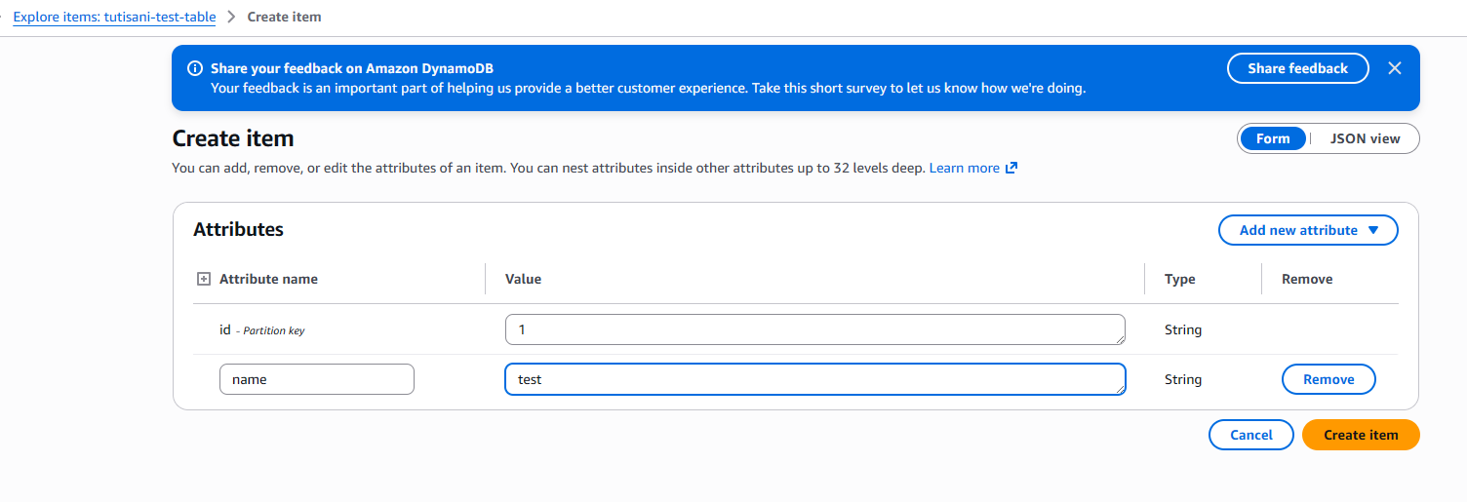
Figure 20. Creating Items
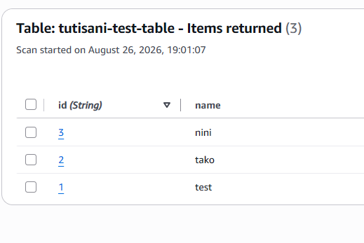
Figure 21. Manually populated items
Then I deleted this table to clean up.
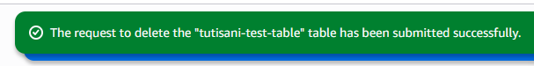
Figure 22. Deleting the manual test table

Creating the Real Table via AWS CLI
For the actual task, I needed to use CLI commands. The task requires justifying my choice of primary key, so I designed a sensible schema: an orders table where order_id is the partition key.
Why order_id as partition key? DynamoDB distributes data across partitions based on a hash of the partition key. For good performance, you need a key with high cardinality (many distinct values) and even access patterns. An order_id (unique per order) meets this, every order goes to a different partition, avoiding "hot partitions." If I'd chosen something like status (only 4–5 possible values: "pending," "shipped," "delivered," "cancelled"), all traffic would concentrate on a few partitions, causing throttling.
I opened PowerShell and ran:
aws dynamodb create-table `
--table-name tutisani-orders `
--attribute-definitions AttributeName=order_id,AttributeType=S `
--key-schema AttributeName=order_id,KeyType=HASH `
--billing-mode PAY_PER_REQUEST `
--tags Key=owner,Value=student `
--profile students-role `
--region eu-central-1
The AttributeType=S means String, KeyType=HASH means partition key (as opposed to sort key, which would be RANGE), and PAY_PER_REQUEST means I pay per operation (not reserved capacity). The output showed the table transitioning to CREATING status.
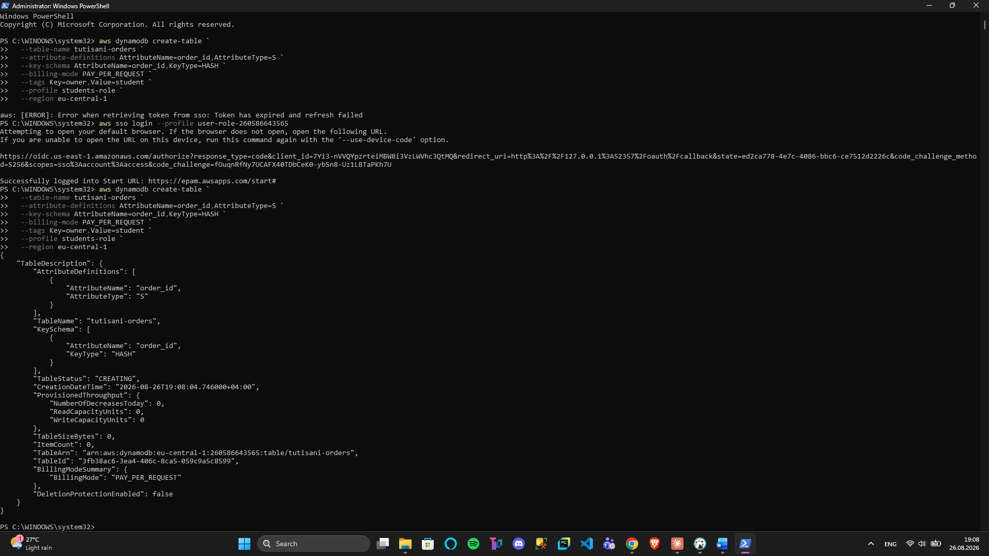
Figure 23. CLI table creation
I verified it reached ACTIVE status which is shown in Figure 24.
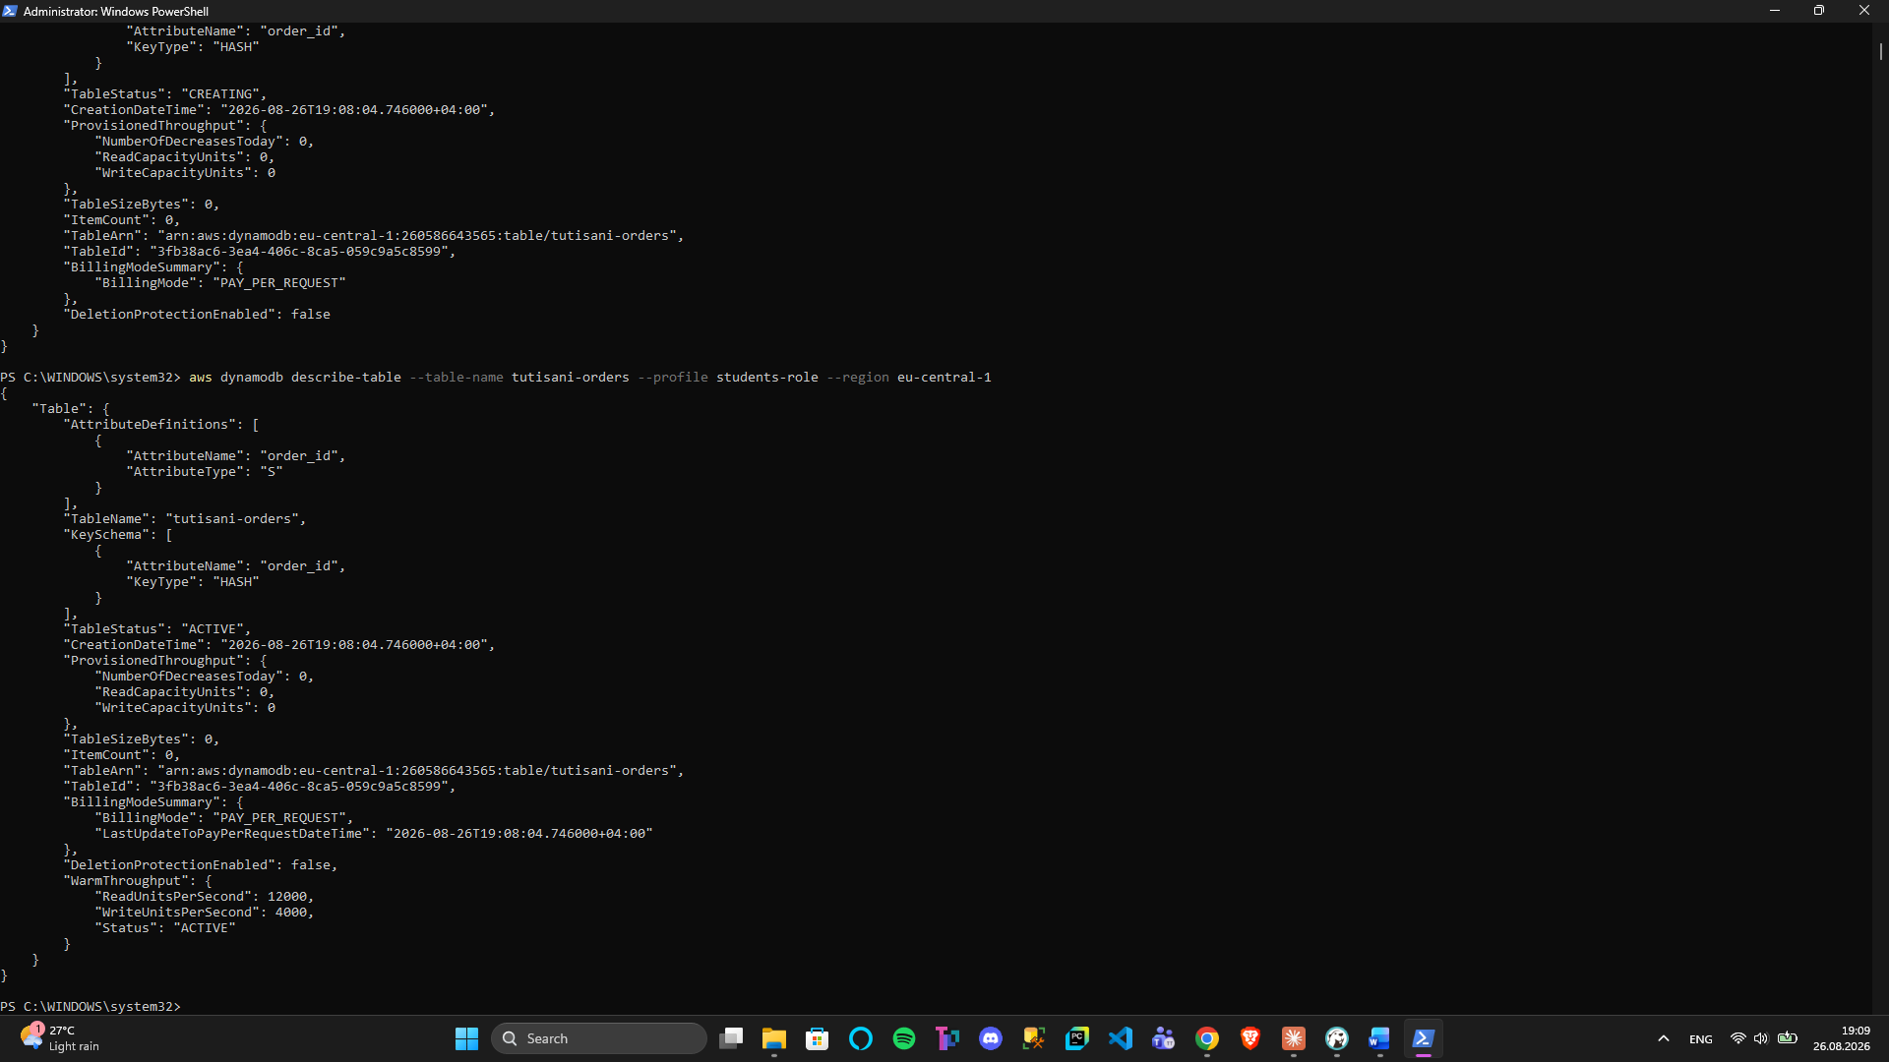
Figure 24. Table active confirmation

Batch Loading 20+ Items
Doing 20 individual put-item calls would be tedious and slow. Instead, I created a JSON file with 20 order records and used batch-write-item to load them all at once, this is more efficient and realistic for production data ingestion.
I created items.json:
{
"tutisani-orders": [
{"PutRequest": {"Item": {"order_id": {"S": "ORD-001"}, "customer_name": {"S": "Alice Brown"}, "amount": {"N": "120.50"}, "status": {"S": "Shipped"}}}},
{"PutRequest": {"Item": {"order_id": {"S": "ORD-002"}, "customer_name": {"S": "Bob Green"}, "amount": {"N": "45.00"}, "status": {"S": "Pending"}}}},
...
{"PutRequest": {"Item": {"order_id": {"S": "ORD-020"}, "customer_name": {"S": "Tina Foster"}, "amount": {"N": "375.60"}, "status": {"S": "Delivered"}}}}
]
}
(20 items total, each with order_id, customer_name, amount, and status attributes.)
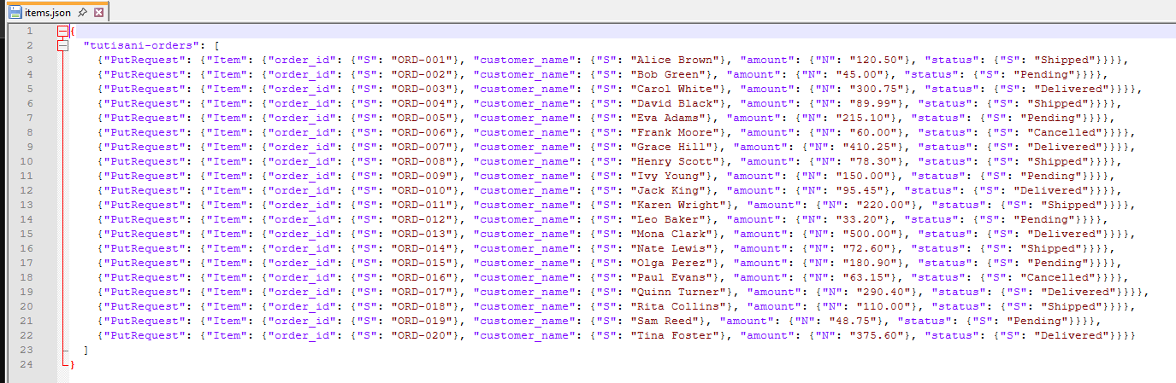
Figure 25. The items.json file content
Then I loaded them:
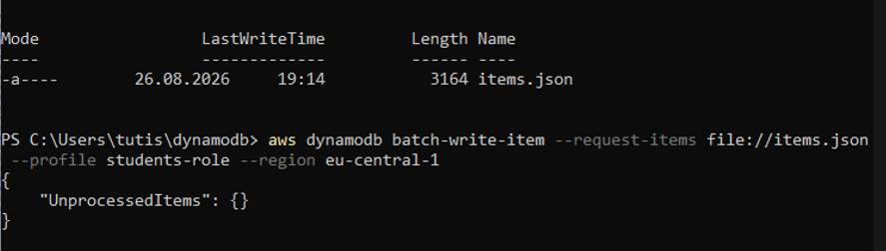
Figure 26. Batch load of 20 rows
The response showed "UnprocessedItems": {}, meaning all 20 succeeded in a single batch operation.

Retrieving 5+ Rows Using Keys (get-item)
Since my table has only a partition key (no sort key), each get-item retrieves exactly one row by that key. I ran five separate get-item calls to demonstrate key-based retrieval:
aws dynamodb get-item --table-name tutisani-orders --key '{"order_id": {"S": "ORD-001"}}' --profile students-role --region eu-central-1
aws dynamodb get-item --table-name tutisani-orders --key '{"order_id": {"S": "ORD-005"}}' --profile students-role --region eu-central-1
aws dynamodb get-item --table-name tutisani-orders --key '{"order_id": {"S": "ORD-010"}}' --profile students-role --region eu-central-1
aws dynamodb get-item --table-name tutisani-orders --key '{"order_id": {"S": "ORD-015"}}' --profile students-role --region eu-central-1
aws dynamodb get-item --table-name tutisani-orders --key '{"order_id": {"S": "ORD-020"}}' --profile students-role --region eu-central-1
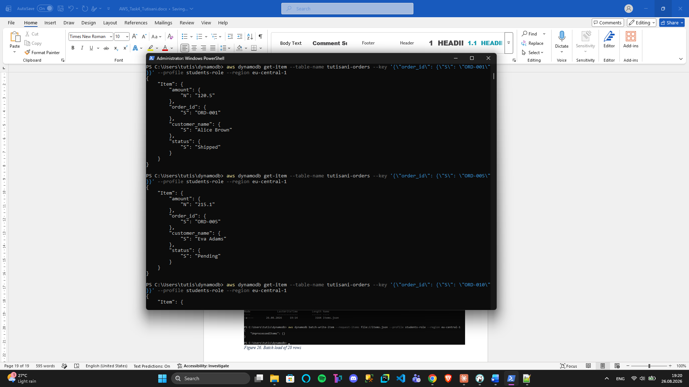
Figure 27. Retrieving items by key

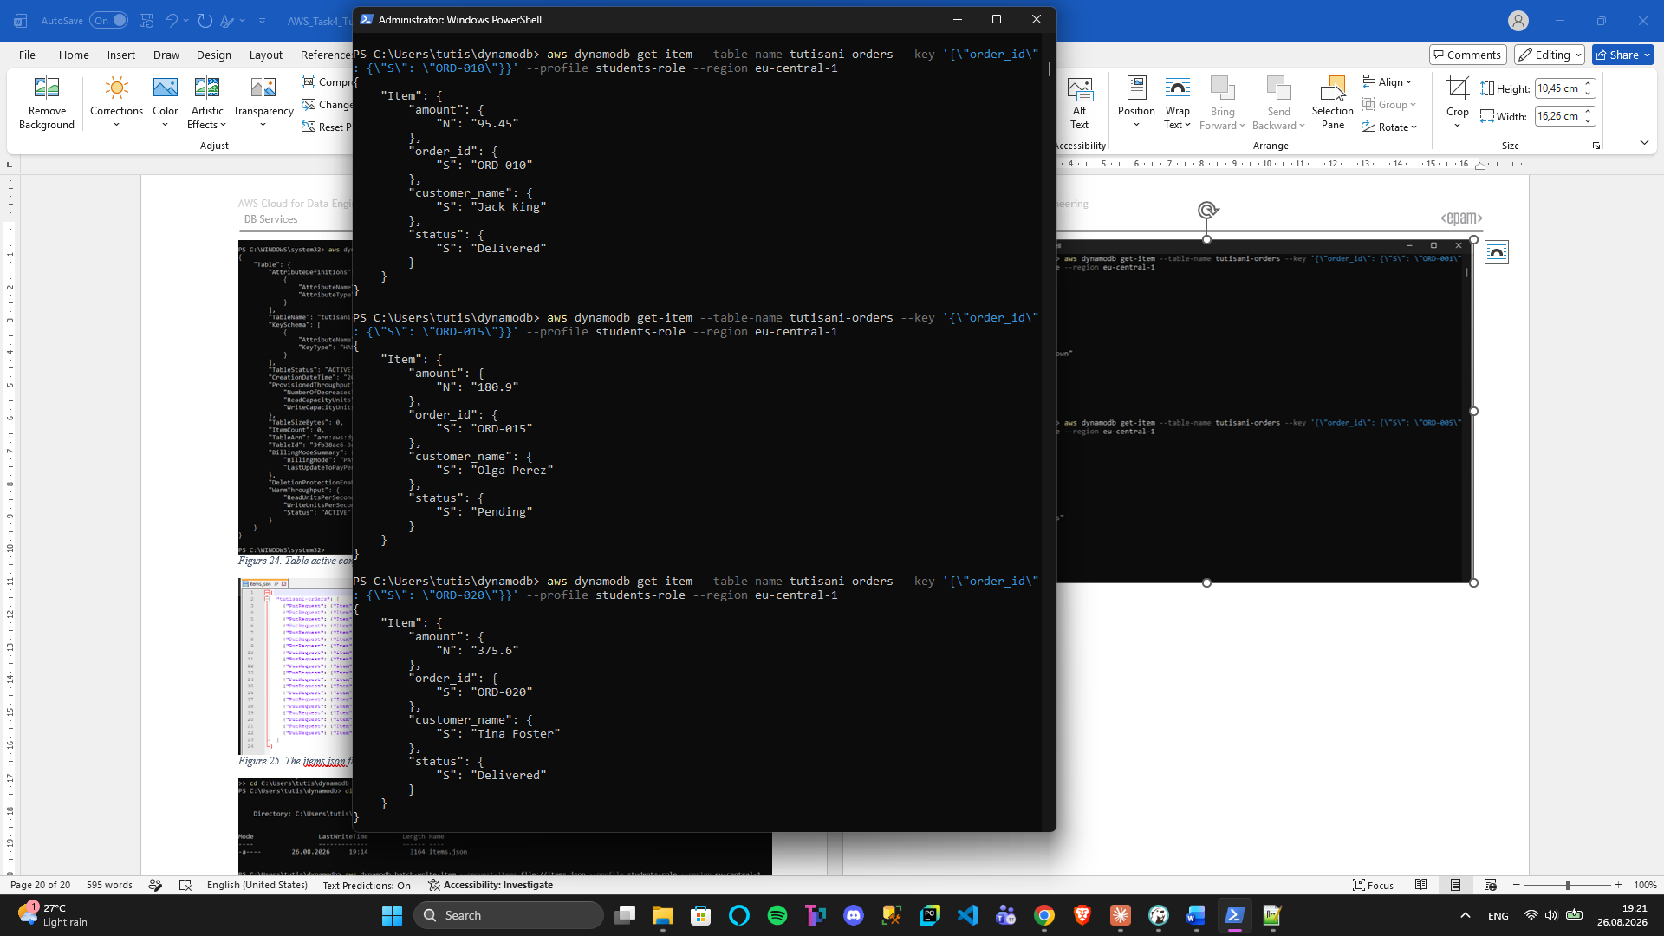
Figure 28. Retrieving items by key
Each returned a full item object with all attributes (order_id, customer_name, amount, status).

Running Several "Select"-Style Queries
DynamoDB doesn't use SQL, it has query (targeted key lookup) and scan (full table read with optional filtering). I demonstrated three different query patterns:
Query 1: Scan with filter expression (find all shipped orders)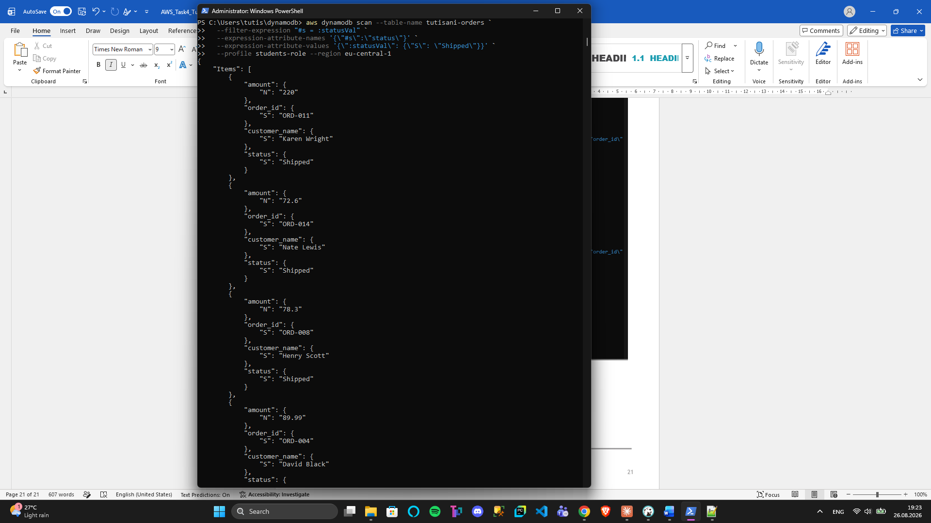
Figure 29. Scan filtered by status
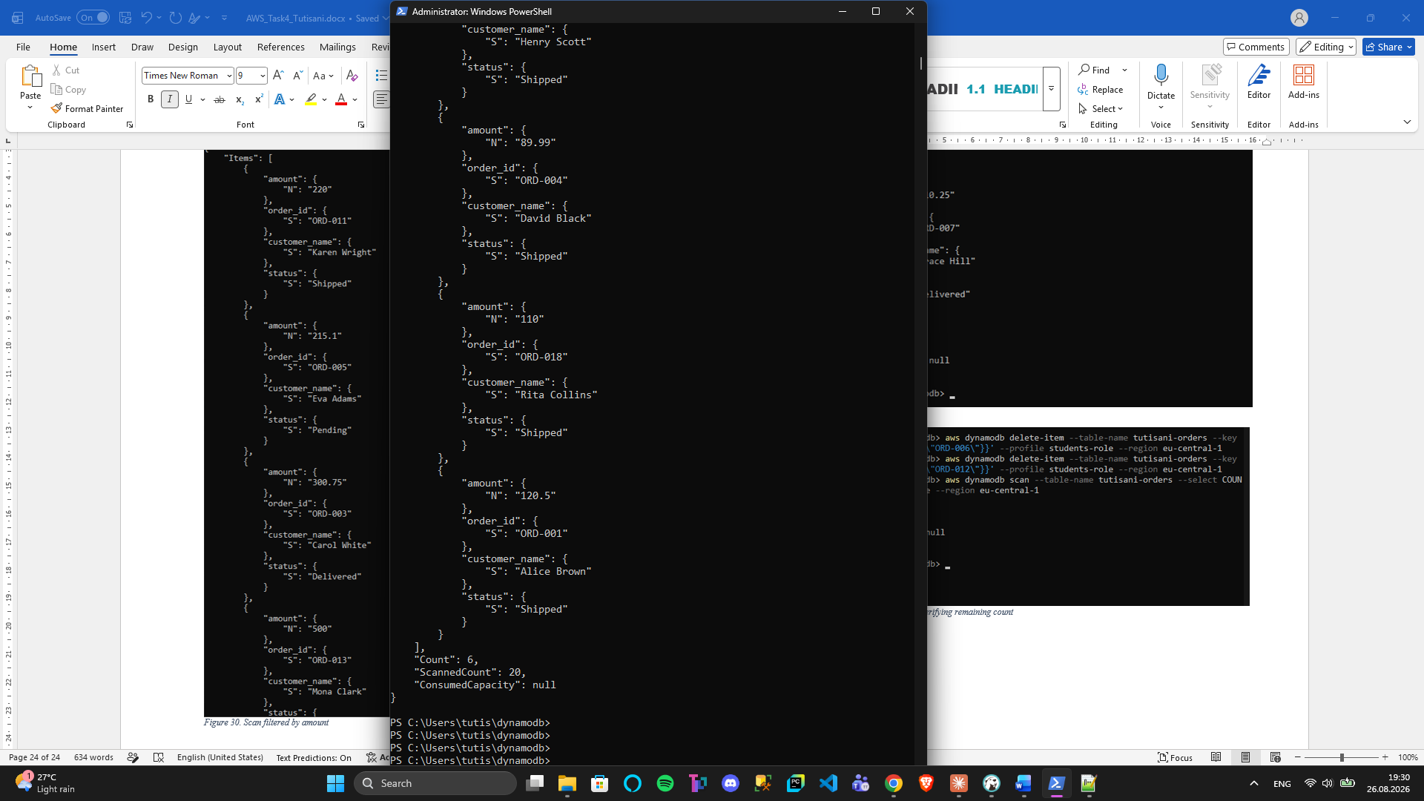
Figure 30. Scan filtered by status pt2
This performed a full table scan but filtered results to only rows where status equals "Shipped." Result showed 4 shipped orders.
Query 2: Scan with numeric filter (find orders over $200)
This scanned the entire table and returned only orders where amount exceeded 200. Result showed 8 qualifying orders.
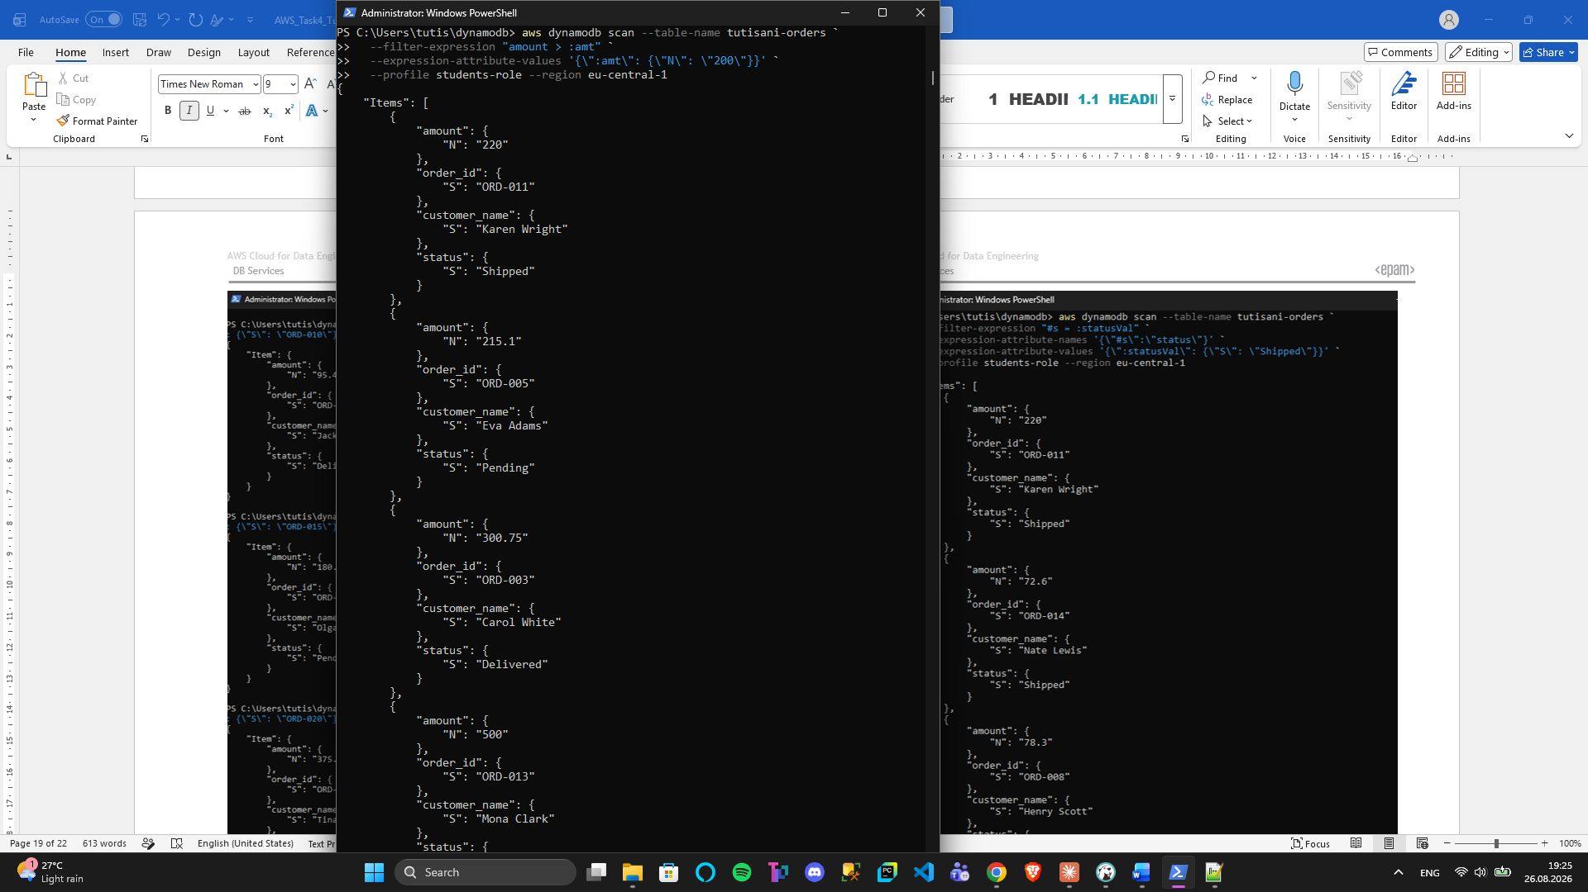
Figure 31. Scan filtered by amount
Query 3: Query by partition key (exact match)
This used the query operation (not scan), which is more efficient, it goes directly to the partition containing ORD-007 instead of scanning the whole table. Result returned exactly one item.
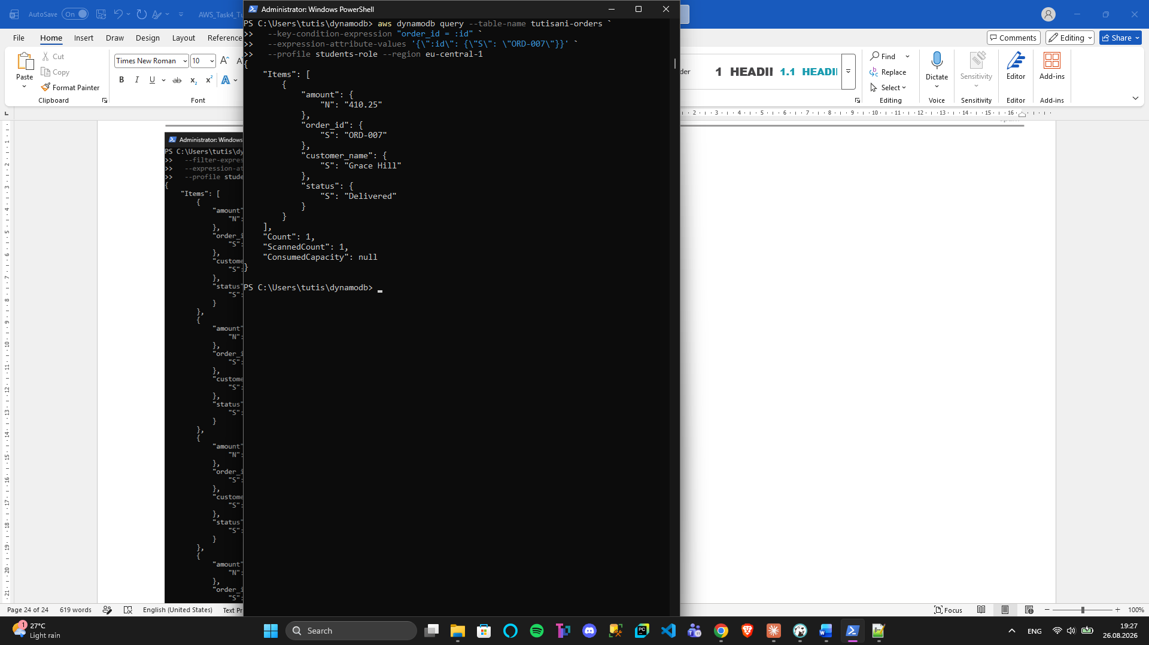
Figure 32. Query by partition key

Deleting 2 Rows and Verifying Count
To demonstrate the delete operation, I removed two items, then I verified the remaining count:
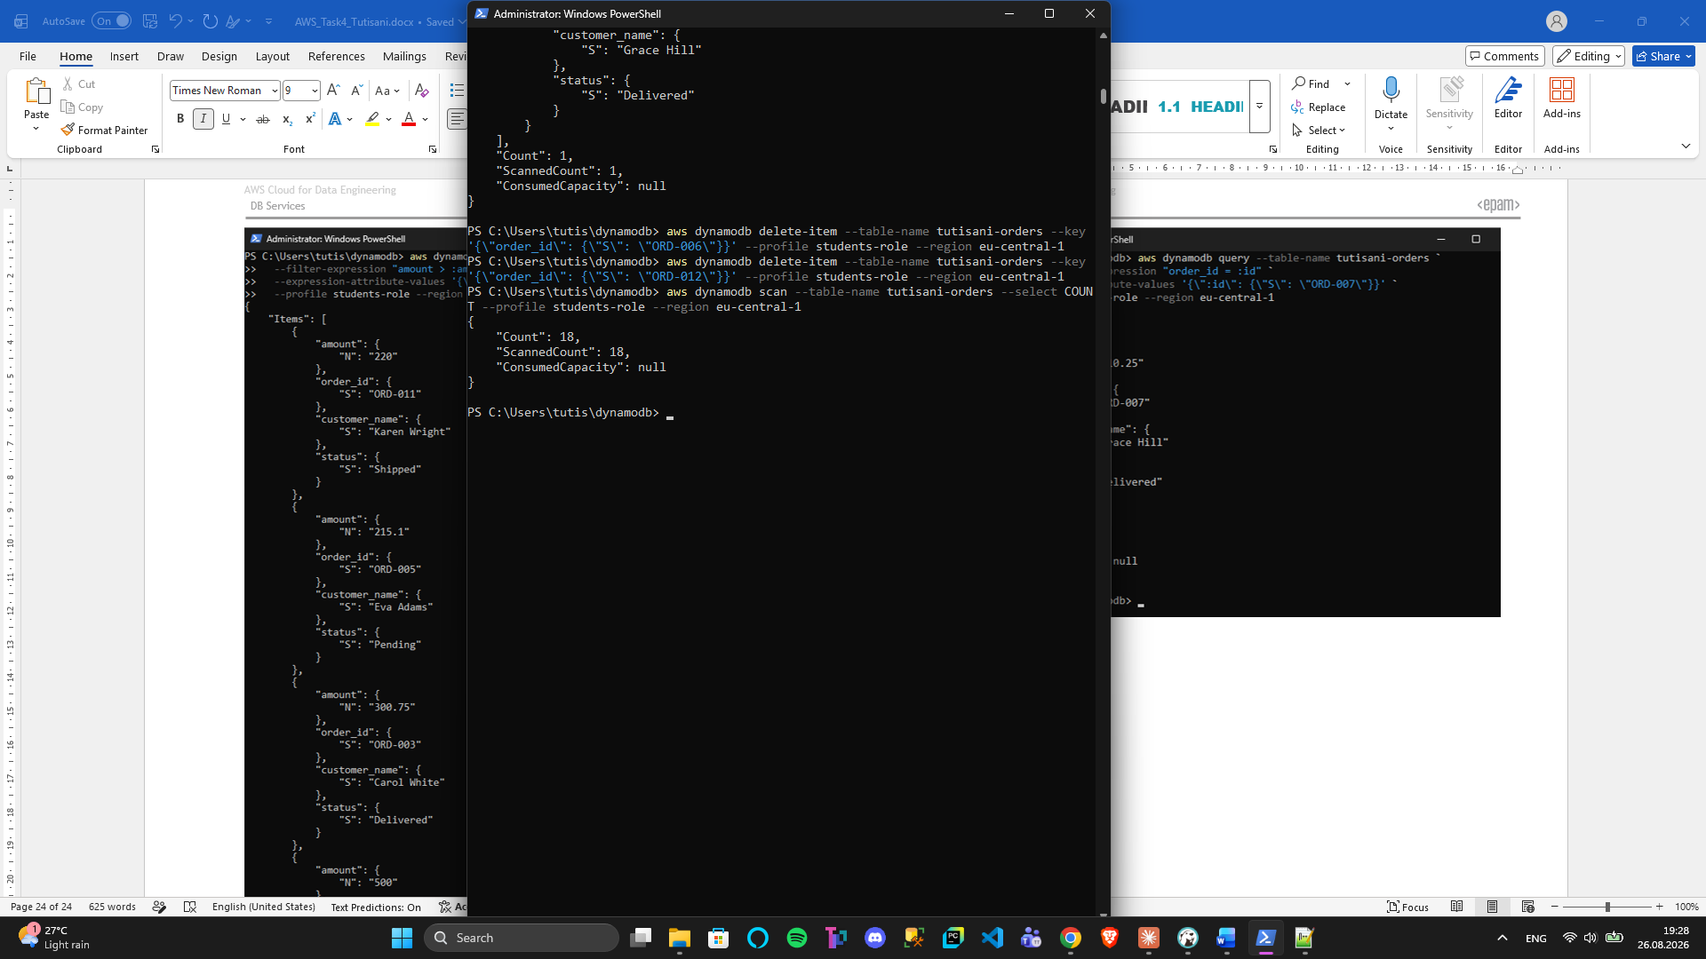
Figure 33. Deleting 2 items and verifying remaining count
The response showed "Count": 18, confirming that 18 items remained (initially it was 20.

SUMMARY AND FINDINGS
This task exposed three distinct database paradigms available in AWS:
- RDS MySQL: A traditional relational database (identical to on-premises MySQL). Useful when you need ACID compliance, complex joins, and schema enforcement. Connectivity is straightforward if the database has a public endpoint.
- RDS Aurora: A managed relational database built on the same MySQL/PostgreSQL engine but with cloud-native features (read replicas, auto-scaling, automated backups). Connectivity from outside the VPC requires a bastion host and SSH tunneling for security, a common pattern in production.
- DynamoDB: A fully managed NoSQL key-value store. No schema, no joins, but extremely fast for key-based lookups and simple scans. Requires different mental models: think about access patterns upfront, design partition keys to avoid hot partitions, and use scan only when necessary.

